Use Case Diagram
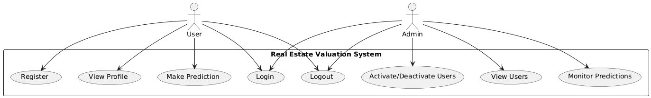

Class Diagram
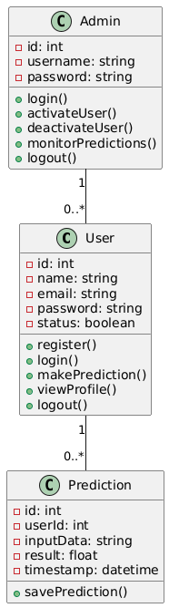

Activity Diagram
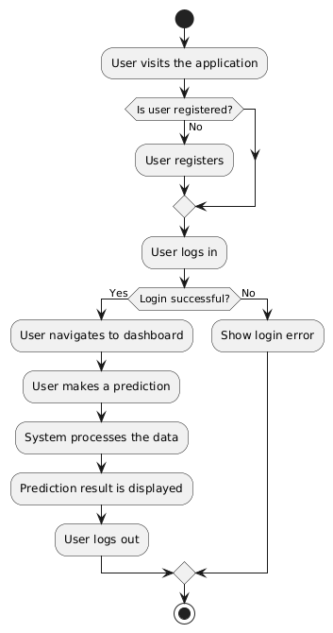
Sequence Diagram
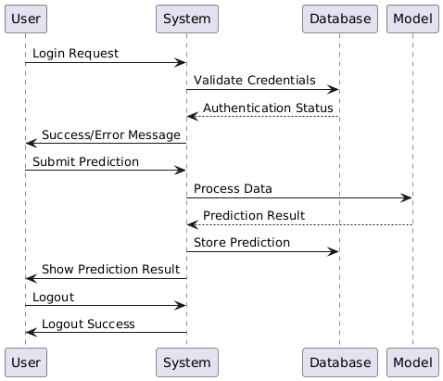

Collaboration Diagram
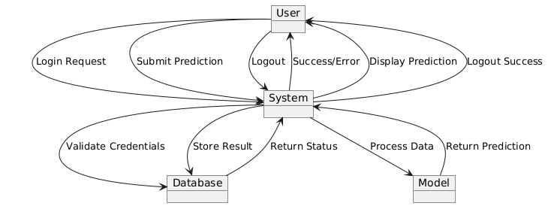
Component Diagram
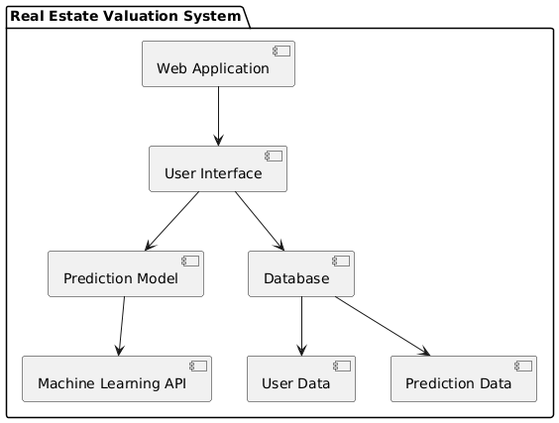

Deployment Diagram
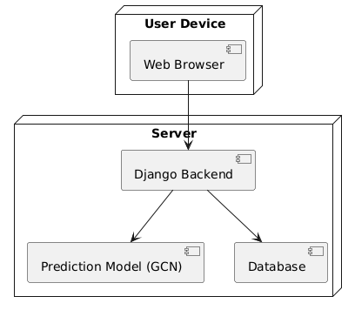
Data Flow Diagram (DFD-0)
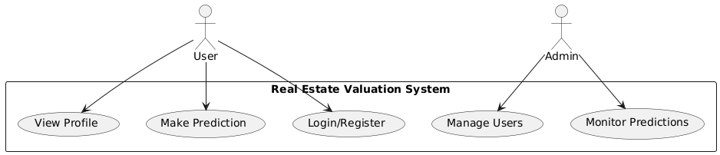

Data Flow Diagram (DFD-1)
